UNITED STATES
SECURITIES AND EXCHANGE COMMISSION
WASHINGTON, D.C. 20549

FORM 8-K

CURRENT REPORT

Pursuant to Section 13 or 15(d) of the
Securities Exchange Act of 1934

Date of report (Date of earliest event reported): June 25, 2026

GD Culture Group Limited
(Exact name of Company as specified in charter)

Nevada |  | 001-37513 |  | 47-3709051
(State or other jurisdiction  of incorporation) |  | (Commission File No.) |  | (IRS Employer  Identification No.)

111 Town Square Place, Suite #1203
Jersey City, NJ 07310
(Address of Principal Executive Offices) (Zip code)

+1-347- 2590292
(Company’s Telephone number, including area code)

Check the appropriate box below if the Form 8-K filing is intended to simultaneously satisfy the filing obligation of the Company under any of the following provisions (see General Instruction A.2. below):

☐ | Written communications pursuant to Rule 425 under the Securities Act (17 CFR 230.425)

☐ | Soliciting material pursuant to Rule 14a-12 under the Exchange Act (17 CFR 240.14a-12)

☐ | Pre-commencement communications pursuant to Rule 14d-2(b) under the Exchange Act (17 CFR 240.14d-2(b))

☐ | Pre-commencement communications pursuant to Rule 13e-4(c) under the Exchange Act (17 CFR 240.13e-4(c))

Securities registered pursuant to Section 12(b) of the Act:

Title of each class |  | Trading Symbol(s) |  | Name of each exchange on which registered
Common Stock, par value $0.0001 |  | GDC |  | Nasdaq Capital Market

Indicate by check mark whether the registrant is an emerging growth company as defined in Rule 405 of the Securities Act of 1933 (§230.405 of this chapter) or Rule 12b-2 of the Securities Exchange Act of 1934 (§240.12b-2 of this chapter).

Emerging growth company ☐

If an emerging growth company, indicate by check mark if the registrant has elected not to use the extended transition period for complying with any new or revised financial accounting standards provided pursuant to Section 13(a) of the Exchange Act. ☐

Item 5.03 Amendments to Articles of Incorporation or Bylaws; Change in Fiscal Year.

Effective as of June 29, 2026 (the “Effective Date”), pursuant to a Certificate of Change Pursuant to Section 78.209 of the Nevada Revised Statutes (“NRS”) GD Culture Group Limited, a Nevada corporation (the “Company”) filed with the Secretary of State of Nevada on June 18, 2026, at which time a 1-for-250 reverse stock split of the Company’s authorized shares of common stock, par value $0.0001 per share (the “Common Stock”) and shares of preferred stock, par value $0.0001 per share (the “Preferred Stock”), accompanied by a corresponding decrease in the Company’s issued and outstanding shares of Common Stock and Preferred Stock (the “Reverse Stock Split”), was effected.

Pursuant to Section 78.207 of the NRS, and pursuant to the Articles of Incorporation of the Company, on June 16, 2026 by unanimous written consent, the board of directors of the Company (the “Board”) authorized the Reverse Stock Split. Pursuant to Section 78.209 of the NRS, the Board may take action to effect the Reverse Stock Split by filing a Certificate of Change with the Secretary of State of Nevada. As previously disclosed, on December 31, 2025 the Company held its 2025 annual meeting of stockholders, during which the stockholders of the Company approved a reverse stock split of the authorized and unauthorized capital stock of the Company, at a ratio ranging between 1-for-2 and 1-for-250, with the exact ratio to be determined by the Board in its sole discretion, to be effected at any time prior to the one-year anniversary of the date of such stockholders’ approval.

The Reverse Stock Split became effective for trading purposes at the market opening on June 29, 2026, at which time the Company’s Common Stock began trading on the Nasdaq Capital Market on a split-adjusted basis under the symbol “GDC.” The new CUSIP number for the Company’s Common Stock post-Reverse Stock Split is 19200A303.

The Company has rounded up to the next full share of the Company’s Common Stock any fractional shares resulting from the Reverse Stock Split. Accordingly, this adjustment reduced the total number of issued and outstanding shares of the Company’s Common Stock from approximately 1.04 billion to approximately 4.16 million, plus any shares to be issued in exchange for fractional interests.

Section 7 – Regulation FD

Item 7.01 Regulation FD Disclosure.

On June 25, 2026, the Company issued a press release with respect to the transactions described above. The text of the press release is furnished as Exhibit 99.1 and incorporated herein by reference.

The information in this Item 7.01 of this Current Report, including Exhibit 99.1 attached hereto, is being furnished and shall not be deemed “filed” for the purposes of Section 18 of the Securities Exchange Act of 1934, as amended (the “Exchange Act”), nor shall it be deemed incorporated by reference in any of the Company’s filings under the Securities Act, or the Exchange Act, whether made before or after the date hereof, except as shall be expressly set forth by specific reference to this Form 8-K in such filing.

The information contained in this Report on Form 8-K of the Company are hereby incorporated by reference into the Company’s Registration Statement on Form S-3 (File No. 333-292934).

Forward-Looking Statements

All statements included in this Current Report on Form 8-K, other than statements or characterizations of historical fact, are forward-looking statements. These forward-looking statements are based on our current expectations, estimates and projections about our industry, management’s beliefs, and certain assumptions made by us, all of which are subject to change. Forward-looking statements can often be identified by words such as “anticipates,” “expects,” “intends,” “plans,” “predicts,” “believes,” “seeks,” “estimates,” “may,” “will,” “should,” “would,” “could,” “potential,” “continue,” “ongoing,” similar expressions, and variations or negatives of these words. These forward-looking statements are not guarantees of future results and are subject to factors, risks, uncertainties and assumptions that could cause our actual results to differ materially and adversely from those expressed in any forward-looking statement, including (but not limited to): the risk that the board may reject the proposal; the risk that any special committee, if formed, may determine not to pursue the proposal; the risk that the consortium may amend, modify, revise or withdraw the proposal; the risk that no definitive agreement will be executed; the risk that financing may not be obtained; the risk that required regulatory, shareholder or other approvals may not be obtained; changes in market conditions; changes in the Company’s capitalization; and other risks described in the Company’s filings with the Securities and Exchange Commission. The forward-looking statements included in this Current Report on Form 8-K speak only as of the date hereof. Additional discussions of factors affecting the Company’s business and prospects are reflected under the caption “Risk Factors” and in other sections of the Company’s Annual Report on Form 10-K for the Company’s fiscal year ended December 31, 2025, and other filings made with the SEC. The Company expressly disclaims any intent or obligation to update any forward-looking statements, whether written or oral, that may be made from time to time by or on behalf of the Company or its subsidiaries, whether as a result of new information, changed circumstances or future events, or for any other reason.

2

Item 9.01. Financial Statements and Exhibits

(d) Exhibits

Exhibits  Number |  | Description
3.1 |  | Certificate of Change filed with the Secretary of State of Nevada
99.1 |  | Press Release - GD Culture Group Limited Announces 1-for-250 Reverse Stock Split Effective June 29, 2026
104 |  | Cover Page Interactive Data File (embedded within the Inline XBRL document)

3

SIGNATURES

Pursuant to the requirements of the Securities Exchange Act of 1934, the registrant has duly caused this report to be signed on its behalf by the undersigned hereunto duly authorized.

 | GD Culture Group Limited
Date: June 29, 2026 | By: | /s/ Xiao Jian Wang
 | Name: | Xiao Jian Wang
 | Title: | Chief Executive Officer, President and  Chairman of the Board of Directors

4

Exhibit 3.1
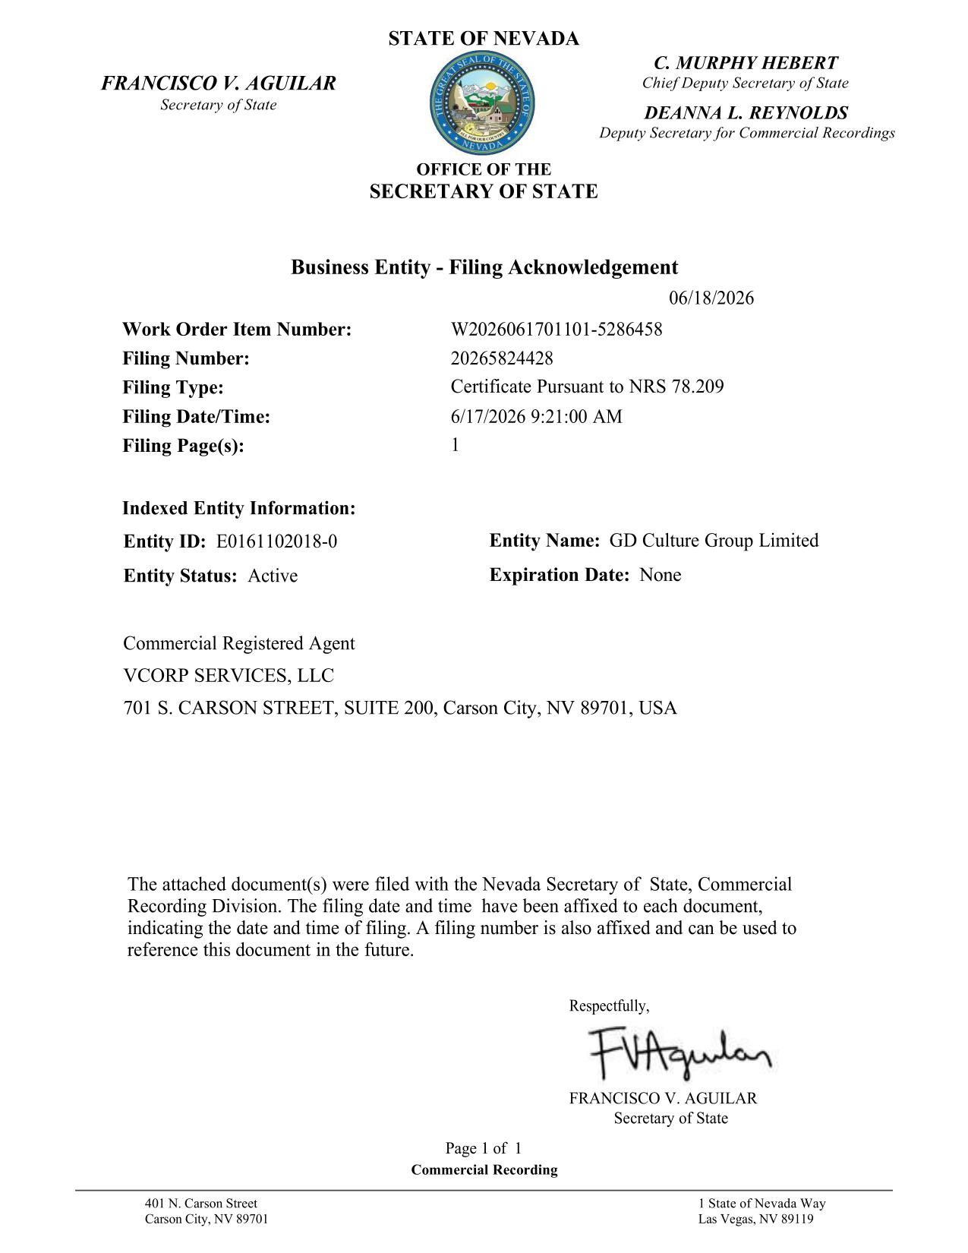

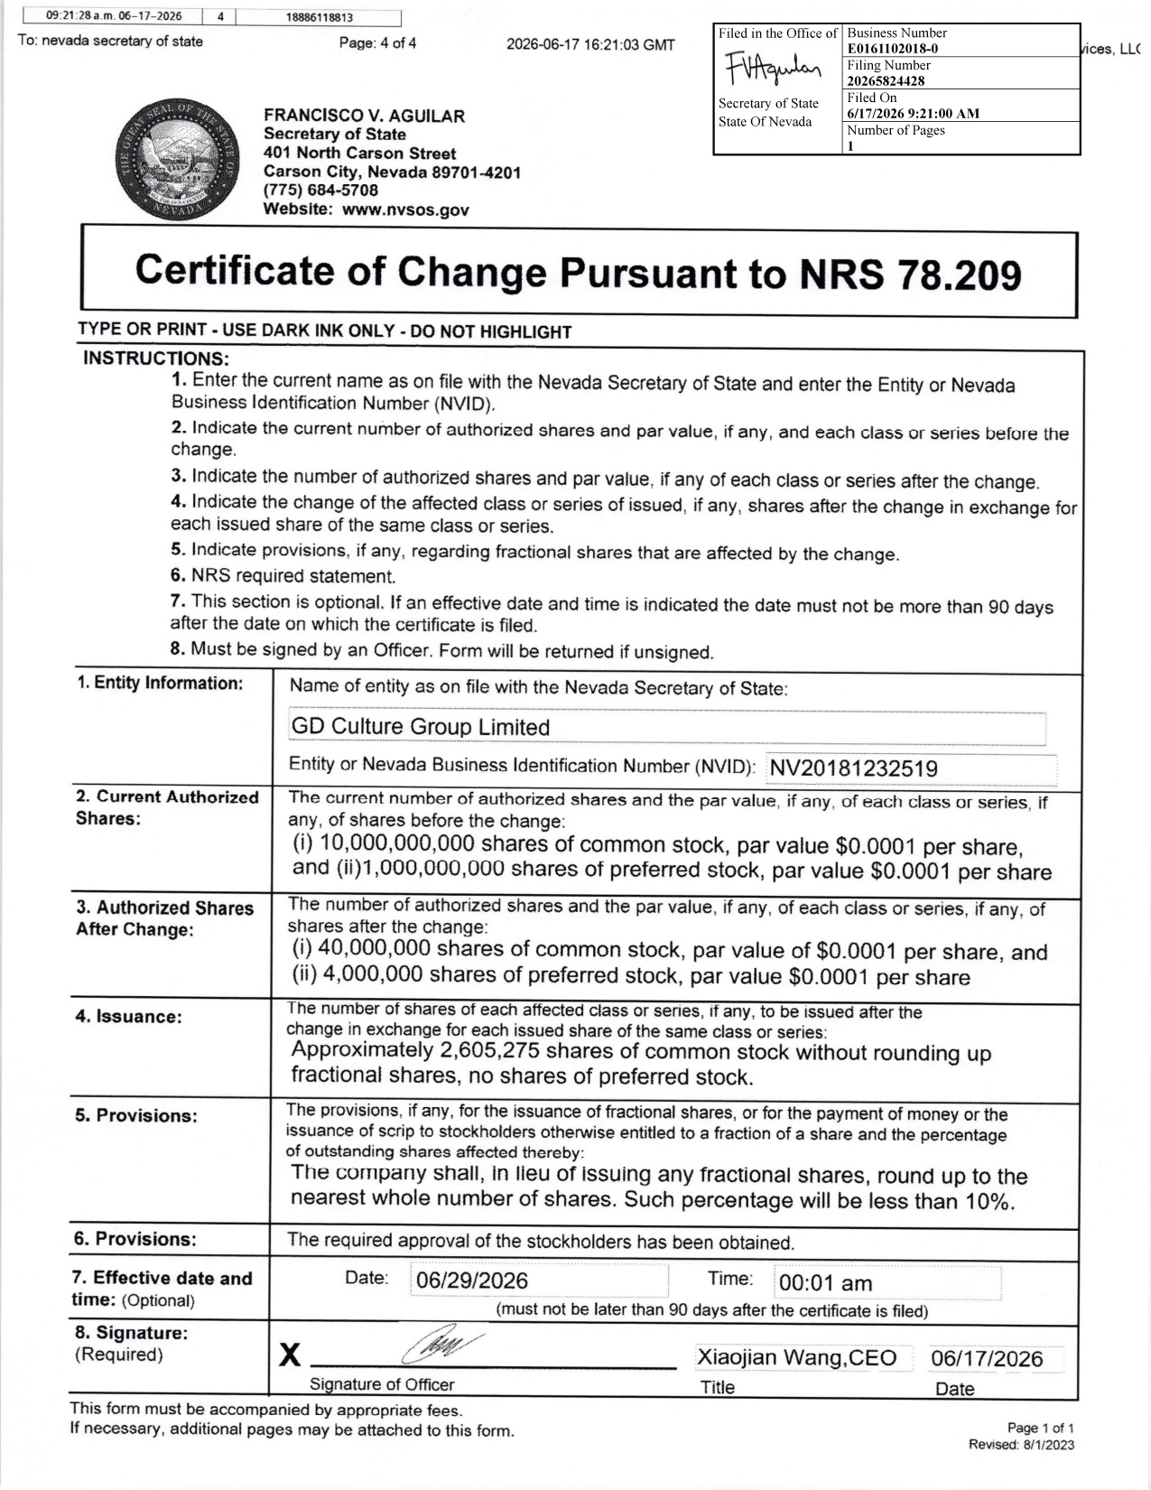

Exhibit 99.1

GD Culture Group Limited Announces 1-for-250 Reverse Stock Split Effective June 29, 2026

JERSEY CITY, N.J., June 25, 2026 (GLOBE NEWSWIRE) -- GD Culture Group Limited (Nasdaq: GDC) (the “Company” or “GDC”) today announced that it will effect a reverse stock split of its issued and outstanding shares of common stock, par value $0.0001 per share (the “Common Stock”) on a one-for-two hundred fifty basis (the “Reverse Stock Split”). The Company’s Common Stock will begin trading on a post-split basis when the market opens on June 29, 2026. The Company’s Common Stock will continue to trade on the Nasdaq Capital Market (“Nasdaq”) under the symbol “GDC” under a new CUSIP number 19200A303.

The Reverse Stock Split is being implemented pursuant to a resolution of the Board of Directors of GDC on June 16, 2026.

As a result of the Reverse Stock Split, each two hundred fifty (250) pre-split shares of Common Stock will be combined into one (1) share of Common Stock, automatically and without any action by stockholders, without any change in the par value per share. After giving effect to the Reverse Stock Split, the Company’s issued and outstanding shares of Common Stock will be reduced from 1.04 billion to approximately 4.16 million, plus any shares to be issued in exchange for fractional interests.

No fractional shares will be issued as a result of the Reverse Stock Split. Stockholders who would be entitled to a fractional share as a result of the Reverse Stock Split shall have their entitlement rounded up to the nearest whole share. The Reverse Stock Split affects all stockholders uniformly and will not alter any stockholder’s percentage interest in the Company’s outstanding shares of Common Stock, except for adjustments that may result from the rounding up of fractional shares.

The Company’s transfer agent, Transhare Corporation, will act as the exchange agent. Adjustments made to the Common Stock represented by physical stock certificates can be made upon surrender of the certificate to the transfer agent. Please contact Transhare Corporation for further information at (303) 662-1112.

About GD Culture Group Limited

GD Culture Group Limited is a Nevada corporation and holding company. The Company is currently undergoing a strategic transition toward leveraging its artificial intelligence and virtual content generation technologies to enter the interactive reading and narrative entertainment market. The Company’s main businesses include AI-driven digital human technology. For more information, please visit the Company’s website at https://www.gdculturegroup.com/.

Forward-Looking Statements

This communication contains “forward-looking statements” within the meaning of the safe harbor provisions of the U.S. Private Securities Litigation Reform Act of 1995. Forward-looking statements include all statements that are not historical facts. Such statements may be, but need not be, identified by words such as “may,” “believe,” “anticipate,” “could,” “should,” “intend,” “plan,” “will,” “aim(s),” “can,” “would,” “expect(s),” “estimate(s),” “project(s),” “forecast(s),” “positioned,” “approximately,” “potential,” “goal,” “strategy,” “outlook” and similar expressions. Examples of forward-looking statements include, among other things, statements regarding assembly and distribution capabilities, decentralized production, and fully digitalized autonomous driving solutions. All such forward-looking statements are based on management’s current beliefs, expectations and assumptions, and are subject to risks, uncertainties and other factors that could cause actual results to differ materially from the results expressed or implied in this communication. For additional risks and uncertainties that could impact the Company’s forward-looking statements, please see disclosures contained in the Company’s public filings with the SEC, including the “Risk Factors” in the Company’s Annual Report on Form 10-K filed with the Securities and Exchange Commission on March 27, 2026 and subsequent Quarterly Reports on Form 10-Q that the Company has filed or may file with the SEC, which may be viewed at www.sec.gov.

For more information, please contact:

GD Culture Group Limited
Investor Relations Department
Email: ir@gdculturegroup.com

Ascent Investor Relations LLC
Tina Xiao
Phone: +1-646-932-7242
Email: investors@ascent-ir.com

